Stephen and Thomas Carrier

The story from the War Memorial this month is about Sergeant Stephen Carrier and Private Thomas Carrier. Stephen and Thomas were not brothers but it is possible that they were related in some way, possibly cousins.

Stephen was a labourer from Wingham before joining the Army. He enlisted in 1911 at the age of 19 years and 11 months in Canterbury, joining the East Kent Buffs. His father was John Carrier of Chapel Row in Wingham, there are no details for his mother. He is also recorded as having one brother, Ernest George who lived in Kingsdown, and four sisters, Ellen, Ella, Ruth and Jane.

According to his service record, Stephen was based in Kent from the 2nd January 1911 until 6th September 1914. During this time he was promoted to Corporal on the 5th October 1913 and on the 31st December 1913 he was awarded a second class physical training certificate. On the 1st September, his Battalion, the 6th, was posted to France to the Western Front. According to Casualty Records he was wounded and transferred to 16 Field Ambulance on the 14th October 1914. On the 25th October he was moved to 5 Casualty Clearing Station. Between August 1914 and April 1915 5 Casualty Clearing Station was based in Hazebrouck in Northern France, in the Flanders area so it is likely that Stephen was wounded somewhere in Flanders. By the 14th November he was moved to a General Hospital and on 30th November he was sent to Aberdeen General Hospital. Stephen was discharged from hospital on the 26th January 1915 and granted sick leave until 18th February which he spent in Wingham.

Stephen was promoted to Sergeant on 1st May 1915 and on the 1st June he was posted back to France, once again to the area around Bailleul and Hazebrouck. The 6th Battalion was part of the 12th (Eastern) Division which had reached Armentieres by July 1915 (south east of Bailleul). The 6th Buffs were among a number of Battalions holding the trenches with a high loss of life. On the 28th August 1915 Stephen was wounded and taken to a Casualty Clearing Station. Stephen died from his wounds on the 7th September, possibly in a General Hospital in Bailleul, aged 23. He is buried in Bailleul Communal Cemetery Extension.

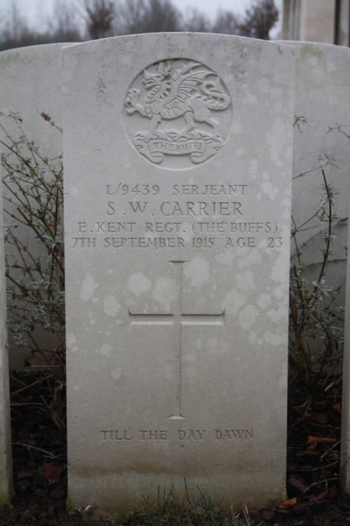
This is a photo of Sergeant Carrier’s headstone which I visited with my family and several friends a few years ago.

Much less is known about Thomas Carrier at the present time. He was a Private in the Grenadier Guards serving in the 4th Battalion. The 4th Battalion was moved to France on 14th July 1915 and came under the command of the 3rd Guards Brigade. He died on the 15th November 1915, aged 36, no doubt as part of the continual attempts to capture Aubers Ridge. He is buried at Aubers Ridge British Cemetery.

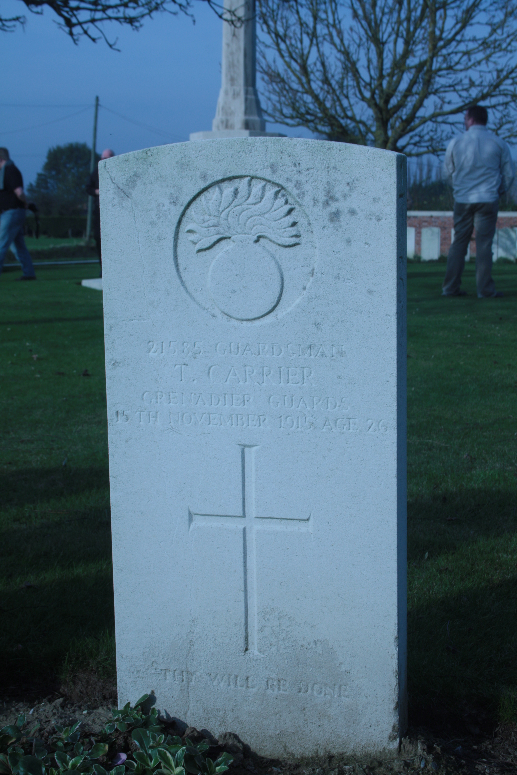
On the Scout Trip to the Western Front in 2011, we paid our respects at the grave of Private Thomas Carrier.

Alison Sims

