Private Ernest Morris

This month the story from the War Memorial is about Ernest Morris. Private Ernest Morris was the son of Mr and Mrs William Morris who lived in Dambridge. Ernest was a Private in the 8th Battalion of the Lincolnshire Regiment. As he was 19 years old when he died, and his military service records have not yet been located, it is assumed that he joined up at 18, a year or so before he died.

The 8th Battalion of the Lincolnshire Regiment had been formed in Lincoln in September 1914 and was raised as one of the new armies. Part of the 37th Division, Second New Army, the 8th Battalion began crossing the English Channel in the summer of 1915. By the time Ernest joined the action, the Battalion had already seen plenty of action in both France and Belgium.

After training, Ernest probably joined the Battalion in late 1916/ early 1917. Having seen action in the Somme the previous year, the spring of 1917 saw the Battalion in action at Arras but by the summer had moved to Ypres Salient. The Battalion remained here throughout the autumn and winter.

In the December of 1917, the 8th Battalion was at Kemmel, South-west of Ypres. The Battalion spent Christmas Day on the front line and was heavily shelled on Boxing Day. They were relieved on the 29th December moving back to Tournai Camp. The winter of 1917 – 18 was a miserable one, first rain and then snow and frozen ground with a freezing wind. Life in the trenches was extremely hard. The 8th Battalion spent February 1918 in three frontline tours of the Tower Hamlets – Dumbarton Lakes sector in Ypres Salient, the third of which was between 9th and 13th March. Private Ernest Morris died on the 9th March 1918, presumably here on the front line.

Private Ernest Morris is today buried in Hooge Crater Cemetery. However it is possible that he was originally buried in Tower Hamlets Cemetery. After the Armistice, Hooge Crater Cemetery, which was designed by Sir Edwin Lutyens, was extended as graves from smaller cemeteries and battlefields were moved there, including those from the Tower Hamlets sector. 5,923 servicemen now lie here.

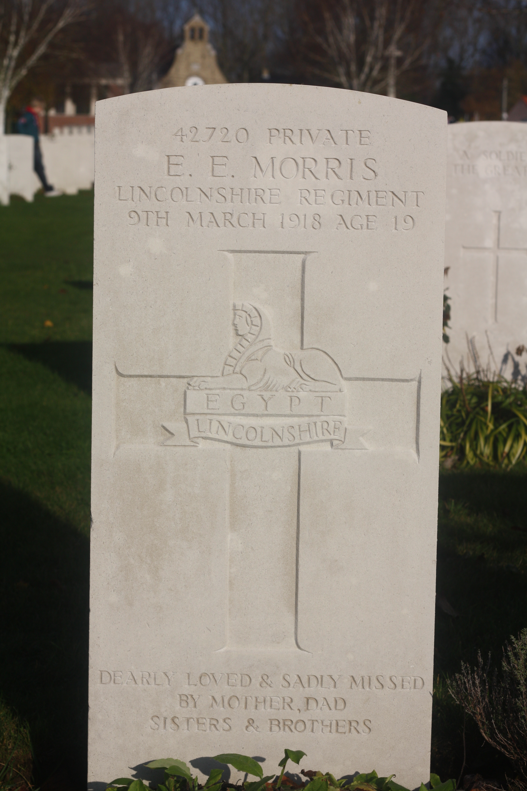

On our trip to Belgium in 2009, the Scout Group visited the grave of Private Morris and we plan to visit again this November on our next trip to Flanders.

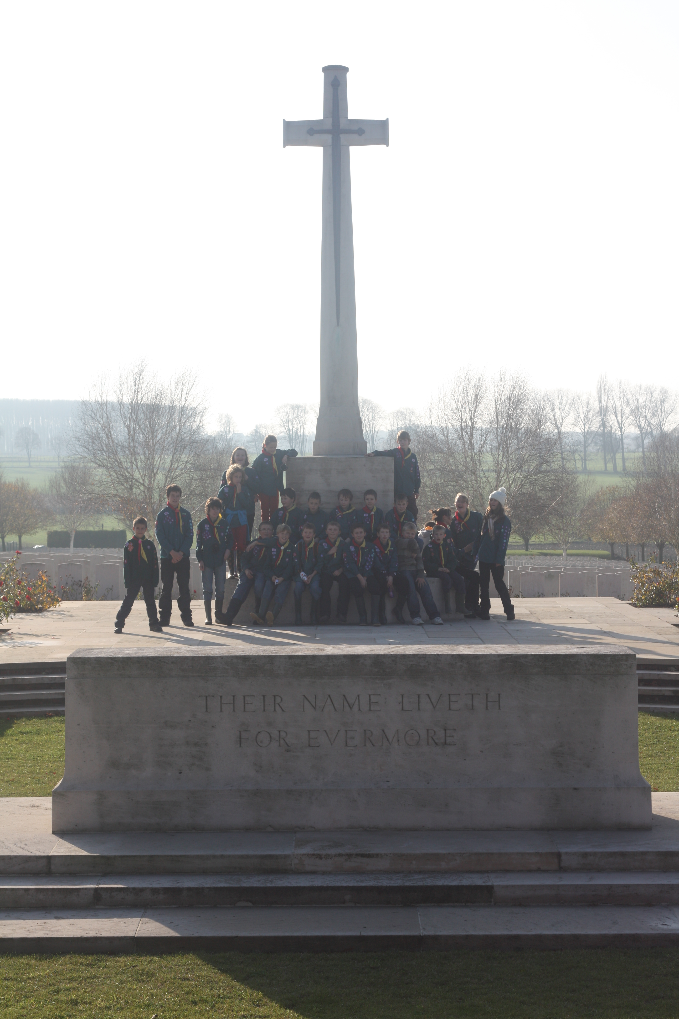

The Scouts at the Cross of Sacrifice at Hooge Crater Cemetery.

Alison Sims

